**Automatic generation/update of a Microsoft Outlook invite for an event upon an event registration in Dynamics 365 Marketing**

**Purpose/Scenario:**

This solution automates sending of an outlook invite for an event when a participant uses portal to register for event or Event Manager adds Event Registration record manually through MDA or through Excel import.

After an outlook invite is sent, if critical session fields in Dynamics 365 Marketing are updated (such as start time, end time), an updated meeting invite gets automatically triggered.

**Assumption:**

Event Registration record creation

OR

Event is updated and “Critical Field” flag is set and event status is “Live”

**Solutions:**

**Unmanaged Solution:** InviteonEventRegistration_1_0_0_0.zip

**Managed Solution:** InviteonEventRegistration_1_0_0_0_managed.zip

**Prerequisite:**

Marketing solution should be installed in the organization on which the above solution is being imported on

**Steps:**

Prerequisite: Marketing solution should be installed in the organization on which the above solution is being imported on

1. Import the solution “MSFT Invite on Event Registration”
2. This solution contains the following components

1. This solution will install two connection references i.e., Microsoft Dataverse and Office 365 Outlook. Post installation of the solution you must configure the above two connection references with the respective users by clicking on the ellipsis and select Edit

1. Two cloud flows
2. Create Invitation when Event Registration is created- This flow triggers when a record gets created in the Event Registration table and sends out the outlook calendar invites to the registered contact for a particular Event. This also updates a field “Outlook Calendar Id” present in the Event Registration table. Using this column, we can identify whether the invites has been sent or not

These steps have to be followed for activating the flows

1. Configure the connection references as mentioned in step 3 and choose the valid references here

For outlook

1. Please select the Calendar Id. This must be done manually because once the connection changes this Id gets changed automatically.

1. This Create Event has a generic Email body. If you wish to change you can change it by modifying the body below

1. In this step we are updating outlook calendar id on Event registration to track whether the invites have been sent or not

Post these steps you can click on Save and Turn on the flow by clicking on “Turn on”

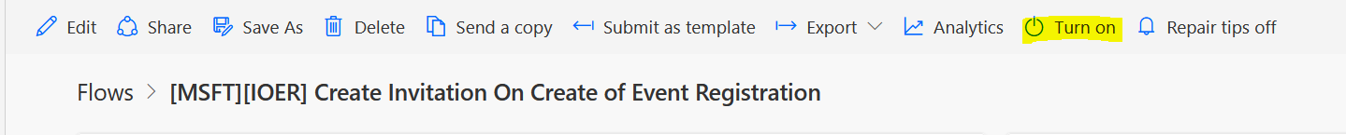

1. Once the flow gets triggered the contact will be receiving a outlook calendar with the sample email body as below.

1. [MSFT][IOER] Send Invitation on Critical Update of Event

This flow will trigger when Critical Update field on Event is set to Yes and Event Status is set to Live. Main usage of flow is to send out the updated outlook invites to all participants(contacts) of Event added as rows in Event Registration table when any details like Event timings are updated.

These steps have to be followed for activating the flows

1. Choose the respect connection references for Microsoft dataverse and office 365 outlook
2. Please select the Calendar Id. This has to be done manually because once the connection changes this Id gets changed automatically.

1. This Create Event and update event actions has a generic Email body. If you wish to change you can change it by modifying the body below

1. After all these are performed you can save the flow the Turn on as performed in the above flow steps
2. Once this flow gets successfully executed, the critical update flag on the Event is set to No by using the below action

Note: All these flows will perform time zone calculations based on the Time Zone field present on Event table